INTERNAL AND CONFIDENTIAL; NOT FOR RELEASE UNTIL 9/13/2021, 7 AM PDT

Sony Contacts:
Larry Smalheiser, Corporate Communications
larry.smalheiser@sony.com

Caroline Mizuki, Imaging Products & Solutions Americas
caroline.mizuki@sony.com

Sony Electronics’ “Visual Story™” Version 2.0 App Adds Compatibility with Video Content

Updated Visual Story App Version 2.0 Now Supports Video in the Story Gallery and Offers Improved Connectivity and Usability for Professional Event Photographers and Videographers

SAN DIEGO, CA – September 13, 2021 – Sony Electronics Inc. today announced the newest version of the “Visual Story” – a mobile application for professional event photographers – and now video creators – that simplifies the process of delivering photos and videos to their clients immediately after an event through gallery creation, AI (artificial intelligence) assistance for easy image selection and web delivery. Visual Story is the perfect tool to deliver an excellent experience for all types of clients and use cases that require immediate delivery, including weddings, corporate events, school activities, sports, and family gatherings. To meet the growing needs of today’s creators, Visual Story will continue to add improvements and enhanced capabilities in future versions.

Wedding | Corporate Event | School Event | Sporting Event

Video Support in Story Gallery
With version 2.0 of the Visual Story app, users can now include video content in a Story Gallery to easily share those special moments with their clients. Once the video files are transferred to the app, users can also easily edit video in the Visual Story app by manually trimming unnecessary portions of each video file uploaded. This new feature is compatible with the Alpha 7S III, Alpha 1 and FX3 camera models.
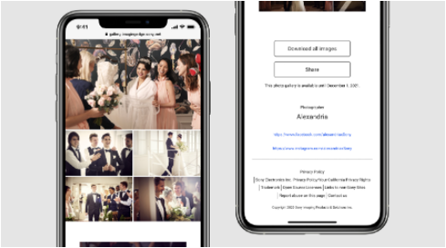
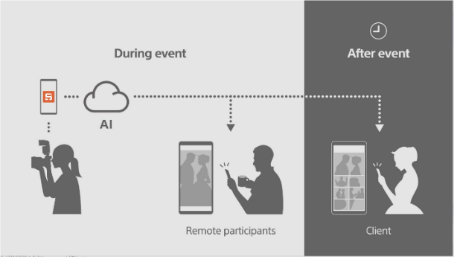

SD Card Reader Support and Mass Storage
In case the network connection at the site of the live event is not strong enough, Version 2.0 now allows users to select and import photos via an SD card reader and a USB mass storage connection. The photographer can connect directly to an Apple SD card reader or directly to a camera in mass storage mode with a USB cable, making it easier than ever to select images and import them into the Visual Story app.

Improved Connectivity and Usability
For easier operation, the app will automatically reconnect if the connection between the user’s smartphone and camera is lost. As an additional benefit, the number of setting options that can be copied from the smartphone to the camera via Bluetooth has increased.

Visual Story Version 2.0 also improves usability based on user feedback. This includes:
- Optimizing import destination settings
- Reconnecting when FTP connection is lost
- Simplifying the number of steps to create a Story Gallery
- Displaying the original file name in a Story Gallery
- Supporting individual downloads for photo and video in a Story Gallery
- Increasing the expiration time for a Live Gallery for up to 24 hours
- Adding background color options in a Story Gallery

Compatibility and Availability
Visual Story Version 2.0 is available now for iOS in the App Store for free and is compatible with select Sony cameras including: Alpha 7C, Alpha 7 III, Alpha 7R IV, Alpha 7S III, Alpha 9, Alpha 9 II, Alpha 1 and FX3^{i}. Cameras from other manufacturers may also be compatible if they support the FTP transfer function.

To make Visual Story available to more users, Sony is planning to expand support to Android later this fall.

Visual Story Version 2.0 is available to download for free HERE

Learn more about Visual Story HERE

Exclusive stories and exciting new content shot with Sony's imaging products can be found at www.alphauniverse.com, a site created to educate and inspire all fans and customers of Sony α - Alpha.

###

About Sony Electronics Inc.
Sony Electronics is a subsidiary of Sony Corporation of America and an affiliate of Sony Group Corporation, one of the most comprehensive entertainment companies in the world, with a portfolio that encompasses electronics, music, motion pictures, mobile, gaming, robotics and financial services. Headquartered in San Diego, California, Sony Electronics is a leader in electronics for the consumer and professional markets. Operations include research and development, engineering, sales, marketing, distribution and customer service. Sony Electronics creates products that innovate and inspire generations, such as the award-winning Alpha Interchangeable Lens Cameras and revolutionary high-resolution audio products. Sony is also a leading manufacturer of end-to-end solutions from 4K professional broadcast and A/V equipment to industry leading 4K and 8K Ultra HD TVs. Visit http://www.sony.com/news for more information.

Notes:

Membership to “Visual Story” account and app on smartphone required with connection to Wi-Fi. See “Visual Story” terms and conditions/privacy policy for details. Download app at the App Store. Network services, content, and operating system and software subject to terms and conditions and may be changed, interrupted or discontinued at any time and may require fees, registration and credit card information. Update to the latest firmware.
Non-Sony models are not covered by the operation guarantee or by support. Users must perform their own trial with any non-Sony brands before purchasing Visual Story.

